

**Jesus Performs His First Miracle**

**John 2:1-12**

Jesus is at a wedding in Cana when the hosts run out of wine. Jesus asks servants to fill jars with water and then makes wine that amazes the guests! It’s the first time Jesus publicly shows that Jesus has God’s power.

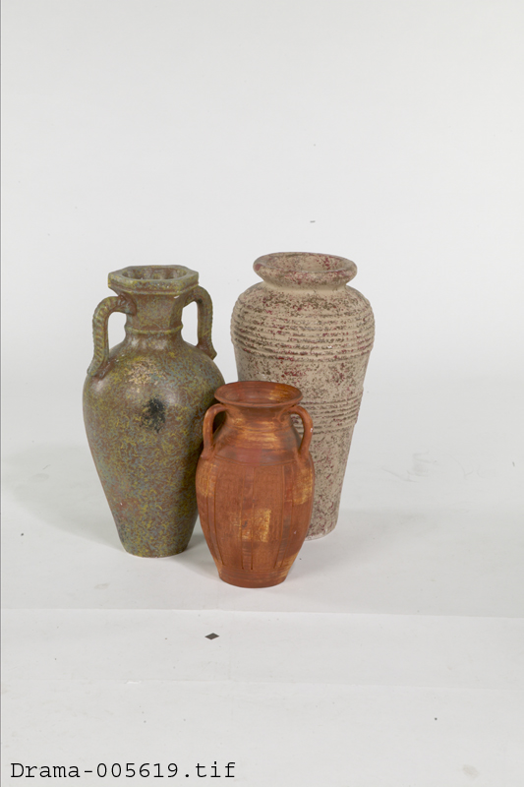

**Church Announcements**

* [Type your content here]

**Family Discussion**

* What does it show you about Jesus that his first miracle happened at a party?
* How do you know Jesus has power?
* What’s a way you need Jesus’ power?

*“This miraculous sign at Cana in Galilee was the first time Jesus revealed his glory. And his disciples believed in him” (John 2:11).*

**Through the Week**

Here’s an activity you can do throughout the week.

1. Start out the week by unplugging everything in your house that requires power (except the refrigerator!). You could even unscrew lightbulbs, too.
2. Whenever someone needs to use a powered device, plug it in or screw in the bulb. (Parents, help younger kids with this.)
3. At the end of the week, count how many things you plugged in throughout the week.
4. Talk about these questions together:
   * **What would it be like to go a whole week *without* any of these devices?**
   * **Which would you miss the most? Why?**
   * **What would it be like not to have Jesus’ power in your life?**

**Fill the Jar**

Celebrate Jesus’ power with this fun family activity.

1. Get out a large jar and some sweetened powdered drink mix.
2. Give everyone a cup of water.
3. Everyone will take turns giving examples of Jesus’ power. These can be from the Bible or personal experience.
4. For each example, that person will pour a little water into the jar.
5. Continue until the jar is full. Then add some powdered drink mix and watch the water turn into “juice.”
6. Pray together that God will fill your lives with his power.
7. Drink the juice together.